English | MONDAY  This week, you will create your very own superhero and send them off on an exciting mission. We can’t wait to see what superheroes you create and to read the adventures that you write.  Starter: Please write the date in your book.  Monday 15th June 2020  Please correct this sentence and write it into your book:  tHe soopur hero That i lighk the best is bAtmAn.  IALT: describe a character. Today, we want you to create your superhero character for the story.  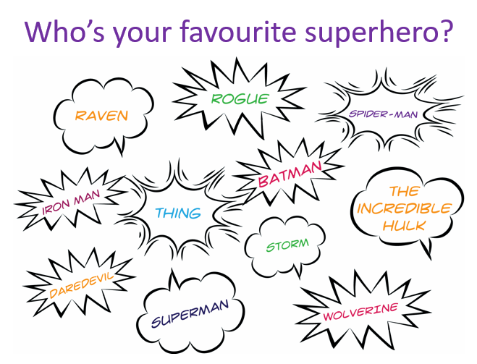  Write down the name of your favourite superhero and any words that you may use to describe them.  Did you use any of these words:  Brave strong kind friendly huge fast clever  Now, you need to make up your own Super hero. Perhaps it will be similar to the Superhero that you have just described.  Task: To create your own Super hero.  - Draw a picture of your Superhero.  - Write the name of your character.  - Label your picture – Use amazing adjectives if you can!!  Example:  This Superhero is called Superspecs. She has incredible x-ray glasses that can see through walls.  Extension: Write sentences to describe your character. What does it look like and what super powers does it have?  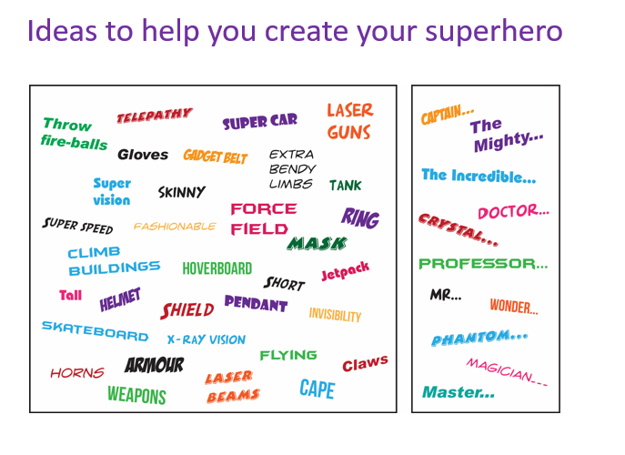
TUESDAY

Starter: Write the date in your book.
Tuesday 16th June 2020
(Remember to use capital letters for days of the week and months of the year)

Please write this sentence correctly into your book:
THe fastest hero iz fLasSH?

IALT: describe a setting.
Today, we are going to think about where your story takes place.

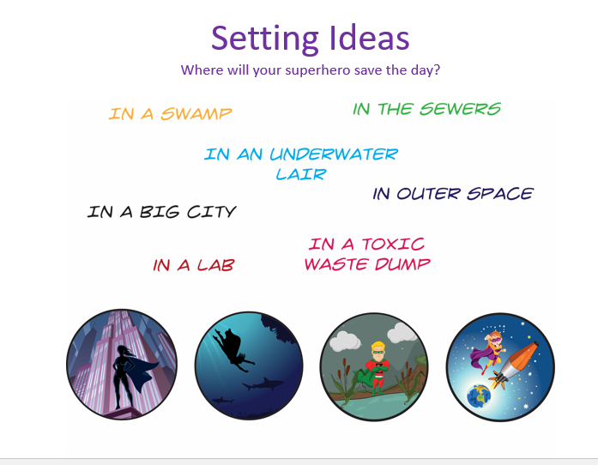

Task:
- Draw a picture of a setting in your story.
- Label the picture – use amazing adjectives.
- Think about your senses:
What does it look like?
What does is smell like?
What can you hear?

Example: 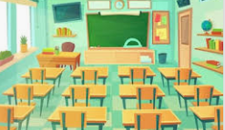
The classroom was filled with rows of wooden desks.

Extension: Use similes to describe your setting.

WEDNESDAY
English | Today, we are going to use speech in our story  Starter: Write the date correctly.  Wednesday 19th June 2020.  Write this sentence correctly into your books.  The evil snayk trapt the little mowse in the room?  IALT: plan a story.  Now that you have created a superhero and decided where your adventure will take place, it is time to plan your story.  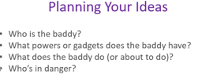:  Your task  - Make a plan for your story.  - How will the story start?  - What will happen in the middle?  - How will your adventure end?  - 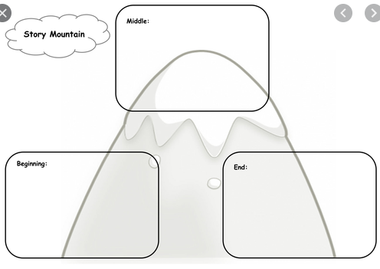  Extension: Add WOW vocabulary to use in each section of your story!

THURSDAY
Today, you are going to write your very own Superhero story!!

Starter: Write the date correctly:
Thursday 20th June 2020.
Write this sentence correctly into your book:
tHe besT super powur is to run as fast as a chEEtur.

IALT: write a story
Look back at the plan that you wrote yesterdat. Read it through and make sure that you can remember the story that you have created.

Your task:
- Read your plan.
- Write a super sentence to start your story. What phrases could you use to start: example: One quiet day……Once upon a time…..

- Write about your character. Use amazing adjectives!
Banana boy was as strong as a lion.

- Write about the problem that happens.
The naughty snake had hidden the treasure.

- How does your super-vegetable come to the rescue?
Banana boy tricked the naughty snake.
- Write an ending for your story.
All the people lived happily ever after.
- Read and check your work.

English | FRIDAY  Each week we will continue to practise learning some words that we may like to use in our writing.  Please choose from Mild, Spicy or Hot words and write them in your book 5 times.  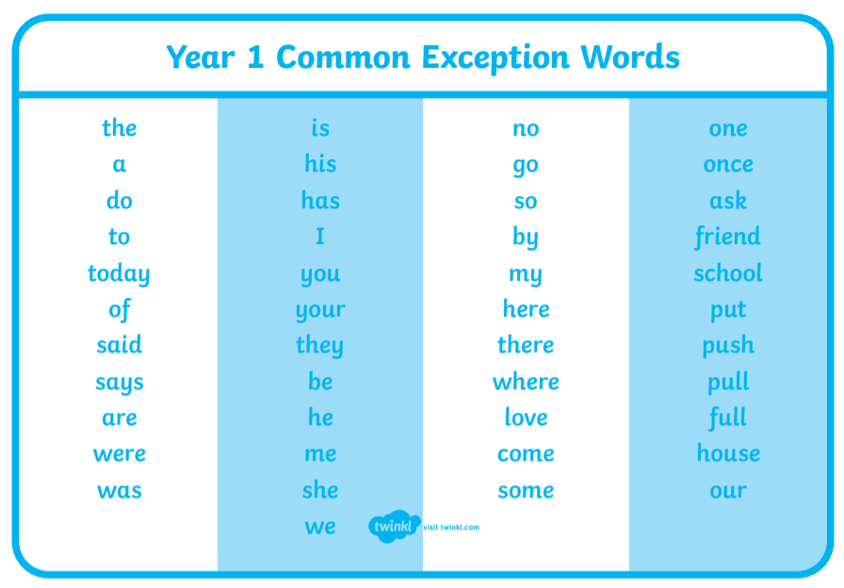  Task:  Mild: Spicy Hot  your there school  were friend full  push house pull  they come push  Extension: Put each word into a sentence and write this into your book.

